**FRIO COUNTY COMMISSIONERS COURT MINUTES FOR**

**Regular Meeting April 9th, 2024**

On the 9th day of April, 2024, at 3:00 p.m., the Commissioners Court of Frio County met in a regular meeting with the following members either absent or present, to-wit: Rochelle Lozano Camacho, Frio County Judge was present; Joe Vela, Commissioner Pct 1 present; Mario Martinez, Commissioner Pct 2 present; Raul Carrizales, Commissioner Pct 3 present; Danny Cano, Commissioner Pct 4 present; Joseph A. Sindon, Legal Counsel for Frio County Commissioners Court present; and Aaron Ibarra, Frio County Clerk present when the following meeting was held, to-wit: The meeting can be seen unedited and to its full extent on our county website, under the County Clerk tab.

I. Invocation and Pledge of Allegiance

II. Adopt Agenda

**MOTION: COMMISSIONER CARRIZALES**

**SECOND: COMMISSIONER CANO**

**MOTION PASSED (WITH EDITS)**

**REMOVE LINE ITEAMS 7 & 2 &**

**15.1 AND 15.2**

III. Old Business

IV. General Discussion

V. Citizens To Be Heard

VI. New Business

**PRESENTATION**

**ACTION AGENDA ITEMS**

(1) Michelle King, Children’s Alliance of South Texas (CAST), requests:

Consider/take action on signing a proclamation designating April as Child Abuse Prevention Month in Frio County, Texas.

**MOTION: COMMISSIONER CARRIZALES**

**SECOND: COMMISSIONER CANO**

**ITEAM PASSES**

(2) Hon. Joe Vela, Frio County Commissioner, Precinct No. 1, requests:

Discussion and update regarding public improvement projects in the City of Pearsall including but not limited to street repairs and traffic control installation devices.

**ITEAM WAS REMOVED**

(3) Ancelmo Ornelas, Frio County Road and Bridge Administrator, requests:

Consider/take action to waive the fee for Fireman’s Park rental for a medical benefit for Sabrina Alaniz on behalf of Frank Cisneros from 5:00 a.m. until 7:00 p.m. on April 13, 2024.

**MOTION: COMMISSIONER CARRIZALES**

**SECOND: COMMISSIONER MARTINEZ**

**COMMISSIONER CANO ABSTAINED**

(4) Hon. Rochelle Camacho, Frio County Judge, requests:

4.1 Consider/take action to approve the Municipal Advisory Agreement between Frio County and the Government Capital Securities for financial advisement.

4.2 If the contract is approved, then sign a resolution authorizing Frio County Judge Rochelle Camacho to enter into same on behalf of Frio County.

**MOTION: COMMISSIONER CANO**

**SECOND: COMMISSIONER MARTINEZ**

**ITEAM PASSES**

(5) Hon. Rochelle Camacho, Frio County Judge, requests:

5.1 Consider/take action to approve the County Information Resources Agency Agreement between Frio County and the Texas Association of Counties for county website service and e-mail service.

**MOTION: COMMISSIONER CARRIZALES**

**SECOND: COMMISSIONER CANO**

**ITEAM PASSES**

5.2 If the contract is approved, then sign a resolution authorizing Frio County Judge Rochelle Camacho to enter into same on behalf of Frio County.

**MOTION: COMMISSIONER CARRIZALES**

**SECOND: COMMISSIONER CANO**

**ITEAM PASSES**

**ADOPTED PREMIUM PACKAGE WITH LEVEL 1 ACCESS FOR TONY**

**AND LEVEL 4 ACCESS AARON AND CRYSTAL**

(6) Hon. Aaron Ibarra, Frio County Clerk, requests:

6.1 Review Frio County Commissioners Court minutes for March 26, 2024.

6.2 Consider/Approve Frio County Commissioners Court minutes for March 26, 2024.

**MOTION: COMMISSIONER CARRIZALES**

**SECOND: COMMISSIONER CANO**

**ITEAM PASSES**

(7) Hon. Ricardo “Rick” Ramirez, Frio County Constable, Precinct No. 1, requests:

Consider/take action to designate Room #102 of the Frio Agrilife Extension Building as the office for Frio County Constable Precinct No. 1.

**ITEAM WAS REMOVED**

(8) Tommy Navarro, Frio County Building Maintenance Supervisor, requests:

8.1 Consider/take action on approving Change Order #14 with Sandoval Contracting for the Frio County Building Improvement Project located at 1796 IH 35E, Pearsall, Texas 78061.

8.2 If the change order is approved, consider/take action on approving a resolution authorizing Hon. Rochelle Camacho, Frio County Judge, to enter into same on behalf of Frio County.

**NO ACTION TAKEN**

**BREAK AT 4:23**

**MOTION: COMMISSIONER CARRIZALES**

**SECOND: COMMISSIONER MARTINEZ**

**RETURN AT 4:44**

**MOTION: COMMISSIONER CARRIZALES**

**SECOND: COMMISSINER MARTINEZ**

(9) Hon. Crystal Marquez, Frio County Auditor, requests:

Consider / take action on approving two online applications agreements with Medina Electric, to add new safety lighting at CR 2638 & FM 462, and CR 2660 & FM 3176 in Bigfoot, Texas, including the costs of $100.00 engineering fees for each.

**MOTION: COMMISSIONER MARTINEZ**

**SECOND: COMMISSIONER CANO**

**ITEAM PASSES**

(10) Hon. Crystal Marquez, Frio County Auditor, requests:

Consider / take action on running a Notice for Public Auction ad (below) in the Frio Nueces Current for one week pursuant to Local Government Code Sec. 263.153.  The ad will run in the Frio-Nueces Current on April 11, 2024.

All sales shall be finalized on an “as is, where is” basis and no warranties, either expressed or implied, shall be applicable to any property sold. The county reserves the right to withhold any item from sale and the Commissioners’ Court or its designated representative conduction the sale may reject any offer to purchase property if the Court or representative finds the rejection to be in the best interest of the County.

**MOTION: COMMISSIONER CARRIZALES**

**SECOND: COMMISSIONER CANO**

**ITEAM PASSES**

(11) Hon. Crystal Marquez, Frio County Auditor, requests:

11.1 Consider / take action to approve the budget amendments to the FISCAL YEAR 2023-2024 Frio County Budget, list below:

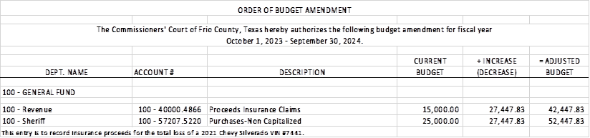

11.2 If the amendment is approved, consider/take action on signing order stating same.

**MOTION: COMMISSIONER CARRIZALES**

**SECOND: COMMISSIONER MARTINEZ**

**ITEAM PASSES**

(12) Hon. Crystal Marquez, Frio County Auditor, requests:

12.1 Consider / take action to approve the budget amendments to the FISCAL YEAR 2023-2024 Frio County Budget, list below:

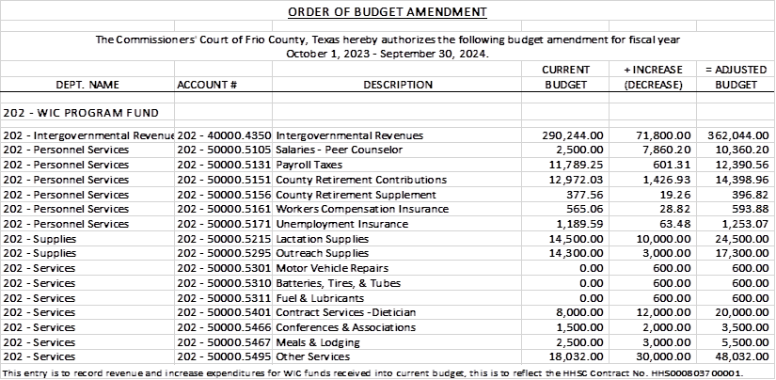

12.2 If the amendment is approved, consider/take action on signing order stating same.

**MOTION: COMMISSIONER CANO**

**SECOND: COMMISSIONER MARTINEZ**

**ITEAM PASSES**

(13) Hon. Crystal Marquez, Frio County Auditor, requests:

Discuss and/or take appropriate action to certify the revenue received, $27,447.83 under the General Fund (fund 100) and add the following line items to the 2023-2024 Budget to receipt the funds and allow expenses:

Account #: **100-40000.4866** PROCEEDS INSURANCE CLAIMS

Account Name: REVENUES

Account #: **100-57207.5220** PURCHASES NON-CAPITALIZED

Account Name: SHERIFF

**MOTION: COMMISSIONER CARRIZALES**

**SECOND: COMMISSIONER CANO**

**ITEAM PASSES**

(14) Frio County Commissioners Court, requests:

Consider/take action on approving a Proposal for two (2) 30-yard solid waste containers for bulk trash pickup in the Pearsall Road and Bridge Yard for a total fee of $2,530**.**00 if two (2) hauls are required or $4,510.00 if four hauls are required.

**MOTION: COMMISSIONER CARRIZALES**

**SECOND: COMMISSIONER CANO**

**ITEAM PASSES**

(15) Hon. Rochelle Camacho, Frio County Judge, requests:

15.1 Discuss, consider, and possibly approve Lone Star Strategy Group, LLC to apply for the FY24 SAFER Grant Program.

15.2 Discuss and take action on the Staffing for Adequate Fire and Emergency Response (SAFER) program grant resolution.

15.3 Discuss and take action on approving and executing the FY24 Community Policing Development (CPD) Microgrants Program grant resolution.

**15.1 AND 15.2 REMOVED FROM AGENDA**

**MOTION: COMMISSIONER CANO**

**SECOND: COMMISSIONER CARRIZALES**

**ITEAM PASSES**

(16) Hon. Rochelle Camacho, Frio County Judge, requests:

Consider/Discuss and approve an authorization to proceed with McKinstry for Schematic Design of the Design Build-Land Development project for the municipal fishing pond.

**MOTION: COMMISSIONER CANO**

**SECOND: COMMISSIONER VELA**

**ITEAM PASSES**

(17) Frio County Commissioners Court, requests:

Receive in person from the following county officials the following reports as mandated by law:

17.1 Presentation by Frio County Treasurer of detailed report as mandated by Section 114.026, Local Government (“Code”) (this report is to be presented at each **regular term of commissioners court).**

17.2 Frio County Treasurer to exhibit the books and accounts of that office for the inspection of the commissioners court (**to be done at each regular term of commissioners court).**

17.3 Consider/take action on authorizing the execution by Frio County Commissioners Court (the Judge and each commissioner) of an affidavit stating the requirements of the treasurer’s report have been met as mandated by section 114.026 of the Code.

17.4 Consider/take action on execution of an order of the commissioners court approving the county treasurer’s report and order their publication in the Frio-Nueces Current as mandated by Section 114.026 of the Code or publication on the county’s website.

**MOTION: CARRIZALES**

**SECOND: MATINEZ**

**ITEAM PASSES**

(18) Frio County Commissioners Court requests:

Presentation, pursuant to Section 114.044 of the Local Government Code, by:

1. Frio County District Clerk;

2. Frio County Clerk

3. Frio County Treasurer

4. Frio County Attorney

5. Frio County Judge

6. Frio County Sheriff

7. Frio County Auditor

8. Frio County Justice of the Peace

9. Frio County Constables

**(who collects or handles any money for the use of the county) of all fines imposed, judgments rendered and collected, and all jury fees collected by the respected courts in favor of or for the use of the county and at that time when the reports are presented to present receipts vouchers that show disposition of the money, fines or judgments.**

After examination by the commissioners court as to the correctness of the reports, consider/action on directing the county clerk to enter information in county finance records as mandated by Section 114.044 of the Code.

**MOTION: CARRIZALES**

**SECOND: CANO**

**MOTION PASSES**

**WITHOUT CONSTABLES 3&4**

(19) Documents (resolutions, orders, contracts, etc.) to be signed.

**DOCUMENTS SIGNED**

(20) Allow bills payable

**MOTION: CARRIZALES**

**SECOND: CANO**

(21) Adjourn

**MOTION: CARRIZALES**

**SECOND: MARTINEZ**